**VPC-Connectivity -TASK-3**

*- Create 2 custom VPC networks*

*- Create 2 subnets in 1st VPC network and 1 subnet in 2nd VPC network.*

*- Create 1 VM in each subnet*

*- Setup Classic route based VPN between the 2 VPCs*

*- 2nd subnet in 1st VPC should not be routable from the 2nd VPC*

*- Ping from VM in 2nd VPC to VM in 1st subnet of 1st VPC*

Classical-VPN

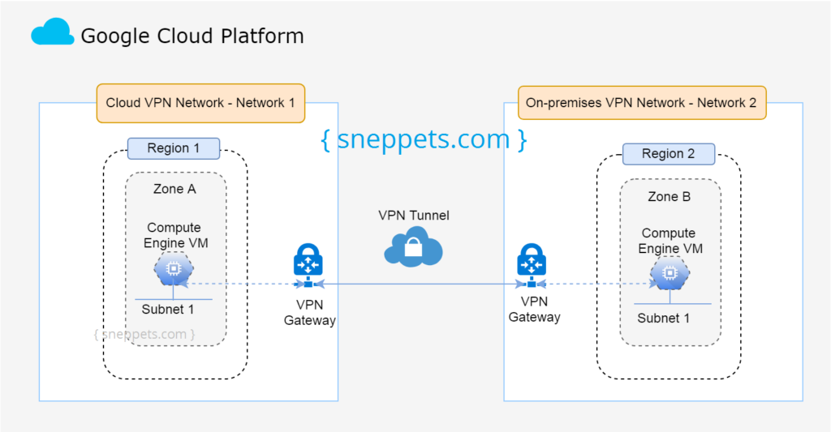

**OVERVIEW**

There are two VPN Gateway connectivity available -

CLASSICAL & HA(high availability)

* In HA VPN you can only provide static routes.
* In classical VPN you can configure only 1 tunnel

while in HA you can provide multiple tunnels hence we get high availability.

* For classical VPN you have to reserve static IP address for the Gateway

For HA VPN you need to create a cloud router which would handle the dynamic routing on its own.

In Google Cloud Platform (GCP), dynamic routing and route-based routing are two different concepts.[Dynamic routing refers to the automatic advertisement of subnets and propagation of learned routes in a Virtual Private Cloud (VPC) network using Cloud Router1](https://cloud.google.com/network-connectivity/docs/router/how-to/configuring-routing-mode). [The dynamic routing mode of a VPC network can be set to either regional or global, and all Cloud Routers in the network use the dynamic routing mode of that network1](https://cloud.google.com/network-connectivity/docs/router/how-to/configuring-routing-mode).

[On the other hand, route-based routing refers to the use of custom routes to define the paths that network traffic takes from a virtual machine (VM) instance to other destinations2](https://cloud.google.com/vpc/docs/routes). [These destinations can be inside or outside the VPC network2](https://cloud.google.com/vpc/docs/routes). Custom routes can be either static or dynamic. [Static routes are manually created, while dynamic routes are automatically maintained by Cloud Routers](https://cloudacademy.com/course/implementing-a-gcp-virtual-private-cloud-1224/routing-in-gcp/).

In summary, dynamic routing is a feature of Cloud Router that allows for automatic route advertisement and propagation, while route-based routing refers to the use of custom routes to direct network traffic

Created two vpc here i.e, vpc-d(two subnets) , vpc-e



Remembering the fact that we have to create Classical VPN gateway

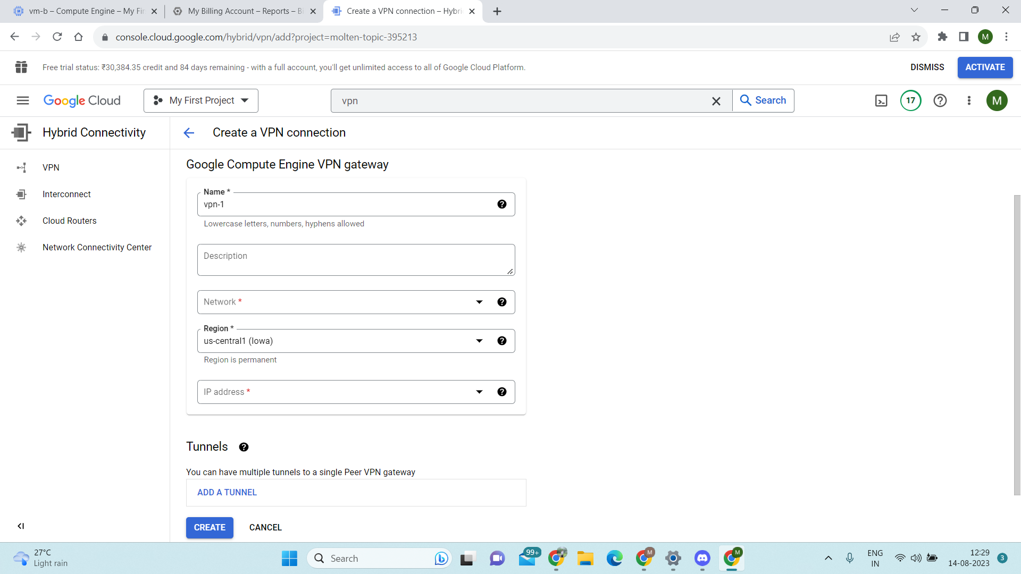

→Select type of VPN as Classical

→Provide it with a proper name

→In Network, we have to give the name of vpc on which we have to provide connection from

→Select the appropriate region

→In ip address– we have to provide a static reserved ip address to it which later on given to tunnel of other side vpc to setup a tunnel connection(ignore the 0 before ip address,get it later)

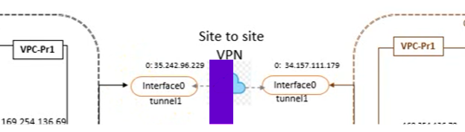

→Create the VPN Gateway -we will add tunnel afterwards

→Create the VPN Gateway for vpc-e also.

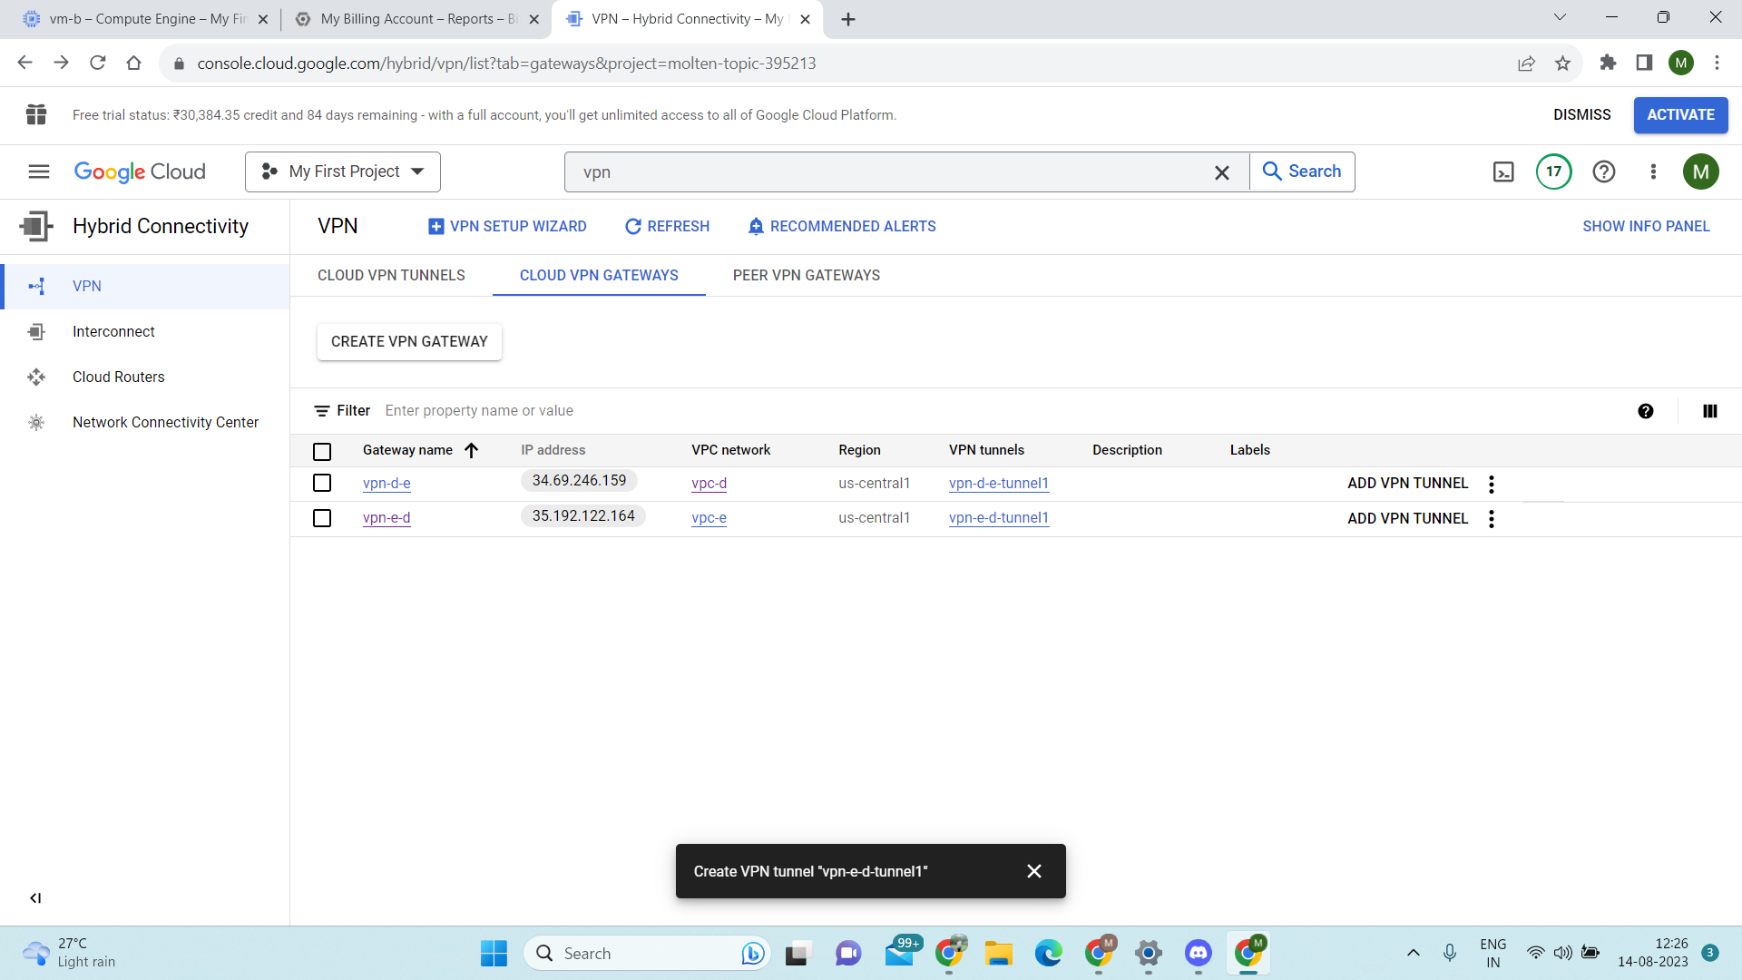

Now after creating both the VPN Gateways we will create the tunnels

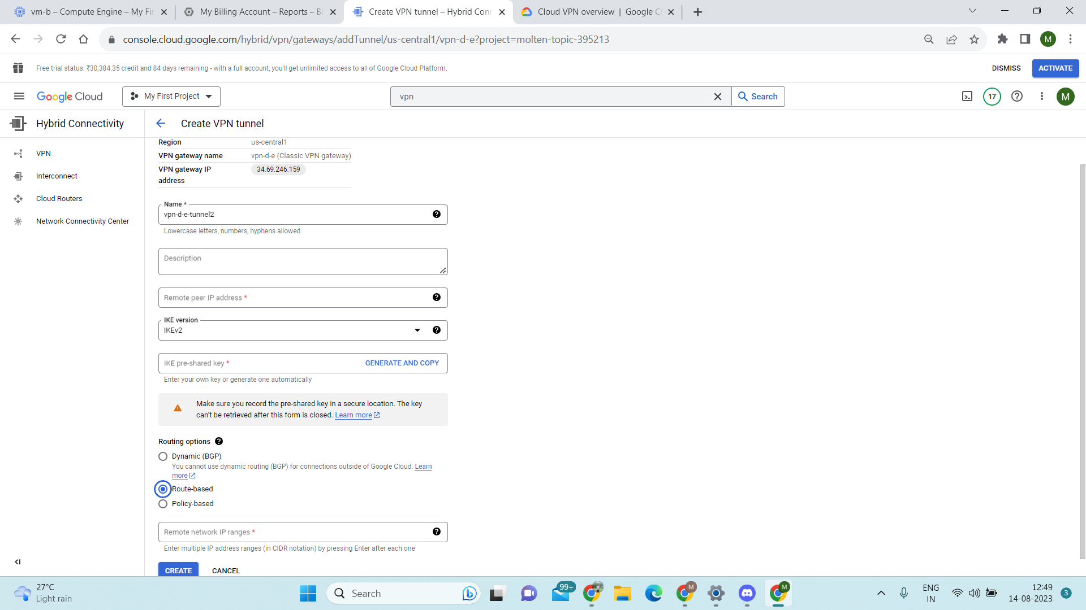

Create tunnel:

Provide a proper name to it.

In remote peer ip address you have to write the ip address that you had created earlier i.e, the static ip reserve address

Shared key is something you need to remember as it is going to be the same for both the ends of the tunnels.

Select route based routing .

And then write a remote network ip range i.e, the ip range of the subnet of another vpc that you want to connect to.

Do the same for other side of the tunnel.

After that you can navigate to the tunnel section and will be able to see the status as healthy in VPN tunnel status.

**After that when you try to ping from vpc-d to vpc-e, it should work  
And when you try to ping other subnet then it will not work as it is not included in configuration.**